**Inventory and Asset**

**Management system**

Project Proposal

By

**Mr. Nathawut Supavananusorn 542115020**

**Mr. Tanadol Parn-ong 542115021**

Department of Software Engineering

College of Arts, Media and Technology

Chiang Mai University

Project Advisor

________________________

**Dr. Prompong Sugunnasil**

**Document History**

|  |  |  |  |  |  |  |
| --- | --- | --- | --- | --- | --- | --- |
| **Document Name** | **Version** | **Status** | **Date** | **Viewable** | **Reviewer** | **Responsible** |
| **Documents** | | | | | | |
| Inventory and Asset Mangement_v0.1.docx | Create Chapter One  -Abstract  -Introduction and Background | Draft | 1 Jan 2015 | NS, TP, PS | NS,TP | TP |
| Inventory and Asset Mangement_v0.2.docx | Create Chapter Two  -Business Review | Draft | 9 Jan 2015 | NS, TP, PS | NS,TP | TP |
| Inventory and Asset Mangement_v0.3.docx | Create  - Technology Review  - Development Tool Review | Draft | 11 Jan 2015 | NS, TP, PS | NS,TP | TP |
| Inventory and Asset Mangement_v0.4.docx | Create  - Chapter Three Quality Standard  - Chapter four Project Plan  1. Motivation  2.Aim and objectives  3.Deliverables and limits  4 Future Work  5.Software Process  6.Schedule & Milestones | Draft | 11 Jan 2015 | NS, TP, PS | NS,TP | TP |
| Inventory and Asset Mangement_v0.5.docx | Fix  -fix page Layout Feature content | Draft | 12 Jan 2015 | NS, TP, PS | NS,TP | TP |
| Inventory and Asset Mangement_v0.6.docx | Fix  -fix abstract  -fix introduction  -fix feature | Draft | 13 Jan May 2015 | NS, TP, PS | NS,TP | TP |
| Inventory and Asset Mangement_v0.7.docx | Fix  -fix abstract content | Draft | 3 June 2015 | NS, TP, PS | NS,TP | TP |

**\*NS = Nathawut Supavananusorn**

**\*TP = Tanadol Parn-ong**

**\*PS = Dr. Prompong Sugunnasil**

**Abstract**

At College of Arts, Media and Technology (CAMT), there are staffs for manage and get informed repair information of durable articles which the durable article will be divided into 2 types consist of IT equipment and other tools that is not about IT. Which we will target on the IT equipment management only. IT staffs of CAMT will record IT equipment information, planning the purchasing, and repair IT equipment information in Microsoft Excel. The informing of the broken IT equipment is done by CAMT’s staffs or lecturers. They will fill broken IT equipment information in informed document and submit to the IT department. As a consequence, IT staff spend a lot of time to manage IT equipment information, use the hard formula in Microsoft Excel, delays to combine the repair detail from other technicians in one place, spend a lot of time to inform the repair detail and assign the task, and the reporter cannot view the history of repair.

The objective of this project is to build a web application for IT equipment management and repair management system. This system is called “Inventory and Asset Management system (IAM)”. The IT equipment management system has the ability to manipulate the information about the IT equipment, and the management information system to analyze information about IT equipment. This system can help the staff to manage and plan for purchasing new IT equipment with ease. This system provides the task distribution system for IT staff. Moreover, this system also provides the tracking system, which helps reporters for tracking reparation process of IT equipment by notification via emails. Repairing system helps IT staff to manage reparation information.

This system consists three users. The first user is administrator. The function of this user is to manage (add, edit, and delete) the IT equipment information, and user account. This user can access to management information system to view the summary report about IT equipment and repairing IT equipment. Moreover, this system provides repair management function to administrator. The second user is the technician. The function of this user is to check the details of inform about broken IT equipment come in and update the reparation information. Finally, the reporter can submit the report and track broken IT equipment.

Contents

**Chapter One | Introduction and Background** 6

**Chapter Two | Literature Review** 7

**2.1**  **Business Review** 7

2.1.1 iSoftService [1] 8

2.1.2 Service Center [2] 10

2.2 Technology Review 12

2.2.1 ASP.NET MVC [3] 12

2.2.2 Cascading Style Sheets 3 (CSS3) [4] 13

2.2.3 HTML5 [5] 14

2.2.4 JavaScript [6] 15

2.3 Development Tool Review 16

2.3.1 Microsoft SQL Server [7] 16

2.3.2 Microsoft Visual Studio [8] 17

2.3.3 Mandrill [9] 18

2.3.4 Window Azure [10] 19

2.3.6 Internet Information Service (IIS) [11] 20

2.3.7 Bootstrap [12] 21

Chapter Three | Quality Standard 21

3.1 ISO 29110 for Very Small Entity (VSE) 22

3.1.1 Project management process 22

3.1.2 Software implementation process 22

Chapter Four | Project Plan 23

4.1 Motivation 23

4.2 Aim and objectives 23

4.2.1 Aim 23

4.2.2 Objectives 24

4.3 Deliverables and limits 24

4.3.1 System Architecture 24

4.3.2 Deliverables 25

4.3.3 Limits 25

4.4 Future Work 25

4.5 Software Process 26

4.6 Schedule & Milestones 27

4.6.1 Features 27

**Chapter Five | References** 34

# **Chapter One | Introduction and Background**

At College of Arts, Media and Technology (CAMT), there are staffs for manage and get informed the repair information of durable articles that the durable article will be divided into 2 types consist of IT equipment and other tools that is not about IT. CAMT has three primary processes for manage the durable article that consist of recording and durable articles information management, the durable articles repair, and planning purchasing the durable articles. For our project, we will target to the IT equipment management only. Currently, IT staffs will record the IT equipment to the Microsoft Excel when they get new IT equipment. If staff team need to inform to repair IT equipment, they need to write an informed document. After that IT staff will assign the task and record the detail to Microsoft Excel. If IT staff can repair IT equipment, the repair information will be recorded to Microsoft Excel and inform to the staff via telephone. If IT staff cannot repair or IT equipment expire or almost expire, IT staff of CAMT will identify it and inform the staff via telephone. IT staff can analyze the IT equipment that expire or almost expire, and the brand of IT equipment that is often broken from Microsoft Excel for planning to purchase new IT equipment in next semester.

From above, the durable articles management has many issues which we will explain by divide IT staff into 2 type which is Administrator and Technician and define the staff to Reporter. For Administrator, Administrator has problems about IT equipment information management which is spend a lot of time to find information on Microsoft Excel and cannot manage IT equipment another devices except his computer. Moreover, Administrator must spend a lot of time to write the hard formula in excel for analyze data for planning. For Technician, Technician spends a lot of time to combined repair detail between technicians in one place, inform the repair detail to Reporter and assign repair task to technician team. For Reporter, Reporter cannot view the history of repair and use many methods to inform the broken IT equipment.

“Inventory and Asset Management system (IAM)” can solve the problems by assisting the process, reporting and managing. Moreover, the management information system is used for summarizing the information of the article based on various criteria. IAM can be helped Administrator to manage user account, record the IT equipment, summary report, and provides repair management function. This system provide Technician to record repair information and view new task notification via email. IAM will support technician to distribute tasks automatically by calculate the average from time to repair in each job of the technician. This system provide Reporter to inform the broken IT equipment and notify the new reparation to Reporter via email.

# **Chapter Two | Literature Review**

## **2.1 Business Review**

Business Review in the present process of IT equipment management within College of Arts, Media and Technology (CAMT), There are three primary processes for manage the durable article that consist of recording and durable articles information management, the durable articles repair, and planning purchasing the durable articles.

The first process, recording and durables articles information management is a process for record the IT equipment to the Microsoft Excel when IT staff get new IT equipment.

The second process, the durable articles repair is a process for inform to repair IT equipment, staff or lecturer need to write an informed document. After that IT staff will assign the task and record the detail to Microsoft Excel. If IT staff can repair IT equipment, the repair information will be recorded to Microsoft Excel and inform to the staff via telephone. If IT staff cannot repair or IT equipment expire or almost expire, IT staff of CAMT will identify it and inform the staff via telephone.

The Third process, planning purchasing the durable articles is a process to analyze the IT equipment that expire or almost expire, and the brand of IT equipment that is often broken from Microsoft Excel for planning to purchase new IT equipment by IT staff in next semester.

Generally, the standard repairing management system will provide the user account system, contributes to managing or allocate jobs of each technician, record broken IT equipment detail and repair information, search IT equipment, and check the progress of repair. So the repair system require functions for IT equipment management, user account management, repair information management, MIS, notification and tracking.

### 2.1.1 iSoftService [1]

iSoftService is an application that’s the repair center can use this system to manage the product repairing, and notify to technicians about their work. This system provides the user to get a servicing report. iSoftService supports major features as follows,

1. This system provides technicians to manage their repairing works.
2. This system provides technicians to record repairing works.
3. This system provides technicians to find their works.
4. This system provides technicians to check the progress of repairing works.

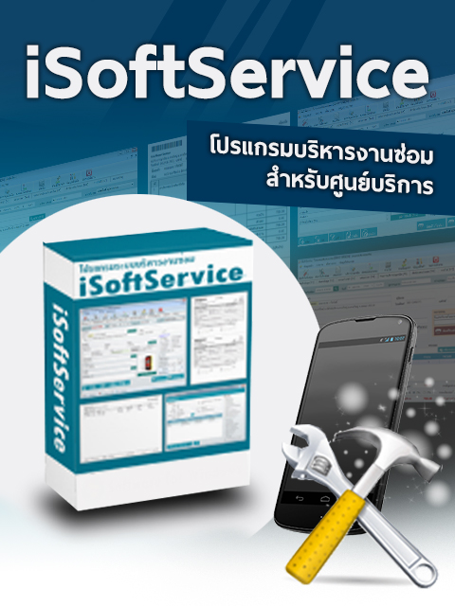

*Figure 1 iSoftService’s logo*

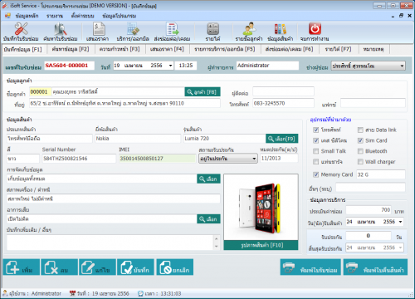

*Figure 2 iSoftService main page Demo Version*

Figure 1 shows iSoftService's logo for sale. There is software interface on iSoftService full box package.

Figure 2 shows the interface of item information page (Demo version) where users can input item information that is repaired. On the right side of Figure 2 provides the user to select an item that is repaired and to display after sales service time.

Pros

iSoftService provide several functions about repairing system for technicians such as recording repairing information, finding servicing information, calculating income, and other functions. This system provides servicing collaboration between departments in the service center.

Cons

iSoftService does not have the tracking system and the system for help to distribute works of each technician equally. iSoftService user interface has function complexity, so this system is hard to use for beginning user.

### 2.1.2 Service Center [2]

Service Center is an application for repairing management. This system uses for repair and installation, such as appliance repair service center, PC repair shop, and mobile repair shop. This system provides the user to view the repair detail and search IT equipment. Service Center supports major features as follows,

1. This system provides the user to record service and repair work.
2. This system provides the user with search product, the status of repair works.
3. This system provides interaction between system and user with friendly interactive.
4. This system provides the user to check information and the progress of repair works.

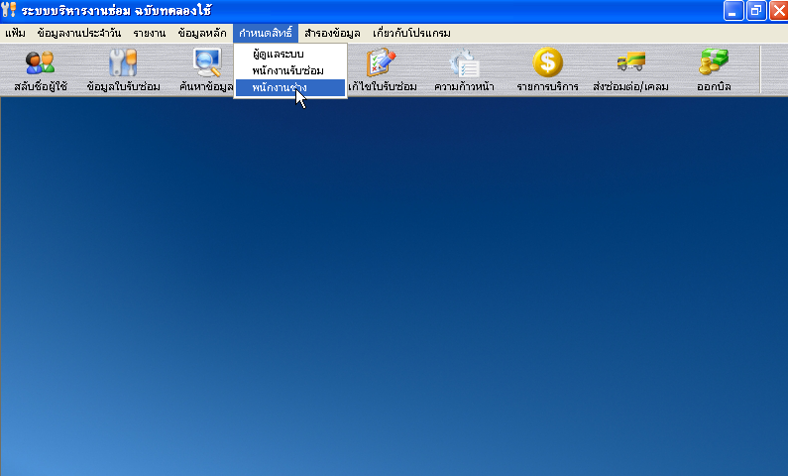

*Figure 3 Service Center main page*

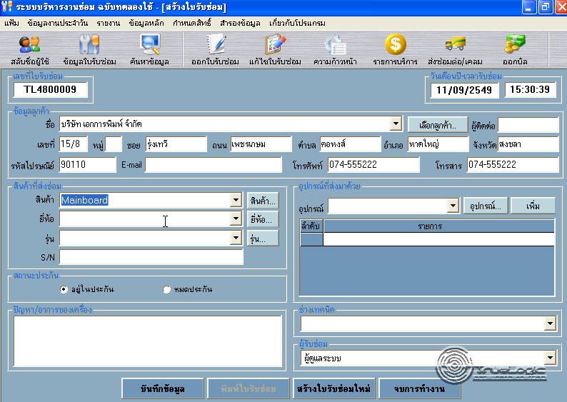

*Figure 4 Service Center repairing information page*

Figure 3 shows the interface of the main page. On the top side of Figure 3 provides the user to use the options menu for repair management.

Figure 4 shows the interface of the repairing page where users can manage repair information. On the left side of Figure 4 provides the user to input the item information.

Pros

Service Center is an application that provides a repairing system to technicians. This system provides basic functions to manage repair information such as the user account and user permission, searching information, and other essential functions, which are appropriate general repair shops.

Cons

This system does not have the tracking system, which affect to the technicians must spend too much time on repair management and distribute works of each technician, because his system cannot work with the internet. This system is hard to use for the user who does not have experience about repair management because there functions a diverse and scattered in a single system.

## Technology Review

### ASP.NET MVC [3]



*Figure 5 ASP.NET MVC*

Technology Description

MVC is a framework for building web application using MVC design pattern. The concept of MVC design pattern will manage (separate) task and element in application to easy for building and development.

Alternative technology

- PHP, JSP

The selection of this technology

. - ASP.NET MVC can build dynamic web application.

- ASP.NET MVC is easy to adapt object oriented programming concept.

### Cascading Style Sheets 3 (CSS3) [4]



*Figure 6 Cascading Style Sheets 3 (CSS3)*

Technology Description

CSS3 is a Style Sheets language to help to define the look and formatting of a document written in a markup language. It is commonly used to create interfaces written in HTML and XHML.

Alternative technology

- CSS2

The selection of this technology

**-** CSS3 is easier to implement page layout

- CSS3 is considered a clean coding technique.

- CSS3 can work with HTML5 and provide a richer set of features (e.g. text effects, 2D/3D transformations, animations).

### HTML5 [5]



*Figure 7 HTML*

Technology Description

Hypertext Markup Language (HTML) is a standard language for using design web pages. HTML use Tag for define HTML displaying. HTML language is a Markup language that use for building web pages. HTML has a template from SGML (Standard Generalized Markup Language) for to understand and easy to learn. Currently being developed and standardized by the World Wide Web Consortium (W3C).

Alternative technology

- HTML4

The selection of this technology

- HTML5 can access sites easier than older version.

- HTML5 is support multimedia content.

- HTML5 is standardized for creating the user interface of website.

### JavaScript [6]



*Figure 8 JavaScript*

Technology Description

JavaScript is a programming language known as the “script”. Translation operates on each command. It is commonly used as part of web browsers, which allow client-side scripts to interact with the user, control the browser, and change the content displayed on the We can add the JavaScript programming web pages to process data of both the display and receiving - transmitting. And that can interact with users immediately. JavaScript is also used in server-side programming and building games as well as desktop and mobile applications.

Alternative technology

- Haxe

The selection of this technology

- We use JavaScript for calculating data, displaying, sending – receiving data for interacting with the user.

- JavaScript is easy to learn.

## Development Tool Review

### Microsoft SQL Server [7]

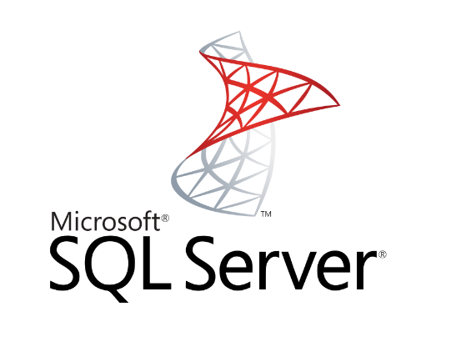

*Figure 9 MS SQL Server*

Tool description

Microsoft SQL Server is a [relational database management system](http://en.wikipedia.org/wiki/Relational_database_management_system) developed by [Microsoft](http://en.wikipedia.org/wiki/Microsoft). As a database, it is a software product whose primary function is to store and retrieve data as requested by other software applications.

Alternative technology

- MySQL

The selection of this tool

- Microsoft SQL Server can use T-SQL language for querying data.

- Microsoft Visual studio can be easily used with Microsoft SQL Server.

### Microsoft Visual Studio [8]

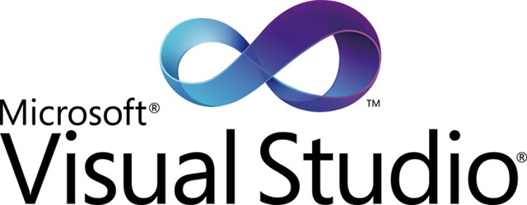

*Figure 10 MS Visual Studio*

Tool description

Microsoft Visual Studio is an integrated Development Environment developed by Microsoft. It enables developers to develop a wide variety of software including web applications and web services that are compatible with Microsoft Windows technologies and devices. Visual Studio supports. Net languages which include VB.NET, C++, C#.

Alternative tool

- Sublime

The selection of this tool

* Microsoft Visual studio is used for developing ASP.NET MVC Framework.

### C:\Users\nathawut\AppData\Local\Microsoft\Windows\INetCache\Content.Word\logo-vertical-light-735b5657.png Mandrill [9]

*Figure 11 Mandrill*

Tool description

Mandrill provides the user to flexible. Mandrill provides the user to send mail from more than one domain within a single Mandrill account, with no additional fees. Mandrill can make the transition to a new dedicated IP easier. Mandrill allows you to send 12,000 emails per month, completely free. Mandrill is a scalable and affordable email infrastructure service. Mandrill has servers around the world which makes to send mail faster.

Alternative tool

- Google Gmail API

The selection of this tool

- Mandrill authenticates your mail automatically.

- Mandrill's IPs are automatically registered for feedback loops with ISPs.

- Mandrill can make the transition to a new dedicated IP easier

- Mandrill provide user send from more than one domain within a single Mandrill account.

### Window Azure [10]

Tool description

Window Azure is a cloud computing platform, which has been developed by Microsoft. Window Azure is used to build, deploy and manage applications and services via a global network of Microsoft-managed datacenters. Window Azure provides Platform as a Service and Infrastructure as a Service also, it supports different programming languages. Platform as a Service use for providing customers rent tools, libraries, storage, operating system and network capacity from the provider. Infrastructure as a Service use for providing customers rent the virtual machine, storage, hardware and server from the provider.

Alternative tool

Amazon cloud drive, Iris cloud computing

The selection of this tool

* We use Cloud service of Window Azure because it is Platform as a Service. Cloud service is containers of hosted applications. These applications can be the web application or private processing engines for works.
* Cloud computing renter can pay an amount of money that depend quantity of resources.
* Window Azure deploy software that was develop by using .Net framework is easily.
* Rate of downtime is less because Microsoft guaranteed rate of uptime is 99.9%.

### 2.3.6 Internet Information Service (IIS) [11]

Tool description

Internet Information Service (IIS) is a web server developed by Microsoft. It is a secure, easy-to-manage, modular and extensible platform for reliably hosting websites, services and applications and provides a set of Internet-based services for servers including HTTP, HTTPS, FTP, FTPS, and SMTP.

Alternative tool

- None

The selection of this tool

* Internet Information Service works with .Net, both of which are developed by Microsoft.
* Internet Information Service is a part of the Window operating system. It is easy to using.

### 2.3.7 Bootstrap [12]

Tool description

Bootstrap is the open source that it is hosted, developed and maintained on GitHub. Bootstrap can help web developer to faster and easier. It's made for folks of all skill levels, devices of all shapes, and projects of all sizes. Bootstrap uses HTML, CSS, and JS framework for developing responsive, mobile-first projects on the web.

Alternative Technology

- Foundation

- Gumby

The selection of this technology

- Bootstrap is a sleek, intuitive, and powerful front-end framework.

- Bootstrap easily and efficiently scales your websites and applications with a single code base.

- Bootstrap is extensive and beautiful documentation for HTML element.

# Chapter Three | Quality Standard

## 3.1 ISO 29110 for Very Small Entity (VSE)

ISO 29110 is a guide applies to a very small entity, enterprise, organization, department or project up to 25 people dedicated to software development. The guide provides project management and software implementation process which integrate practice based on the selection of ISO/IEC 12207 systems and software engineering-software life cycle process and ISO/IEC 15289 software engineering-software life cycle process guideline for the content of software life cycle process information product (documentation) standards elements

### 3.1.1 Project management process

The purpose of the software management process is to establish and carry out in a systematic way the task of the software implementation project which allows complying with the project’s objectives in the expected quality. Time and cost

**Selected process**

3.1.1.1 Project planning process

3.1.1.2 Project plan execution process

3.1.1.3 Project assessment and control process

3.1.1.4 Project closer process

### 3.1.2 Software implementation process

The purpose of the software implementation process is the systematic performance of the analysis, design, construction, integration and test actives for new or modified software products according to the specified requirements.

**Selected process**

3.1.2.1 Software implementation process

3.1.2.2 Software requirement analysis process

3.1.2.3 Software architectural design process

3.1.2.4 Software construction process

3.1.2.5 Software integration process and test process

3.1.2.6 Software delivery process

# Chapter Four | Project Plan

## 4.1 Motivation

The IT staff of College of Arts, Media and Technology found several problems from IT equipment management and IT equipment repairing. Firstly, IT staff records and finds broken IT equipment name, which spend a lot of time. IT staff can record or update information in the administrator computers only. Moreover, they cannot know repairing IT equipment statistic, which it help to decide for purchasing IT equipment in each year. Technicians get repairing work unequally. The reporter cannot check the progress of repairing work. To inform the repair, there are many processes and documents can lose. Moreover, there are many methods for inform broken IT equipment.

Regarding to mentioned problems, we are going to develop Inventory and Asset Management system, which support on web application in order to provide convenient to Administrator, Technician, and Reporter, they can access to this system in everywhere by using the internet. This system is designed for IT equipment management and IT equipment repairing of College of Arts, Media and Technology. We hope our system to support distribution task automatically easier and quicker to the user.

## 4.2 Aim and objectives

### 4.2.1 Aim

- We will divide the user of this system into three types that consist of Administrator, Technician and Reporter. We hope this system can support Administrator with the standard repair management function that consist of the user account management, summary report system, and standard repair management function. This system must provide Technician to record repair information, get new task notification via email which the system can distribute tasks automatically by average from time to repair in each job of Technician. We design the system by inventing functions for Reporter can view new repair notification via email and inform the broken IT equipment by use this system.

### 4.2.2 Objectives

The objective of this project are three parts.

- The first part is to develop the web application that provides the administrator manage user account, record the IT equipment, summary report, and provides repair management function.

- The second part is to develop the web application that provides the technician record repair information and view the new task notification via email, distribute tasks automatically by the average from time to repair in each job of the technician.

- The third part is to develop the web application that supports inform the broken IT equipment and notify the new reparation to Reporter via email.

## 4.3 Deliverables and limits

### 4.3.1 System Architecture

**(Microsoft SQL server)**

DB

**(ASP.NET MVC) M**

Web application

**(IIS)**



**(Google Chrome)**

Web browser

*Figure 13 the architecture of Inventory and Asset Management system*

The architecture of Inventory and Asset Management system is shown in Figure 13. This system consists web application which is created by ASP.NET MVC and database which is Microsoft SQL server. The user can access by using a web browser.

### 4.3.2 Deliverables

-Proposal

-Project plan

-Software requirement specification

-Software design document

-Testing document

-Traceability record

-Software quality assurance document

-Certification client and server system

-Video clips for demo program

-Poster A1 for presentation

### 4.3.3 Limits

- Internet connection is required for using this system.

- Users need to log in before using this system.

- This web application is tested only on Google Chrome only.

- This system can use Mandrill to send 12000 mails per month.

## 4.4 Future Work

The license can be implemented in any faculties. Moreover, this system has many functions for providing computer service and repair center that would like to use the system to support technician and repair center. We hope our system can help the technicians to manage repair work within an organization efficiently.

## 4.5 Software Process

*Figure 13 Iterative development model*

Iterative development model is one of the software development models which evolves from waterfall model. By changing process flow from step to step into iterative step. When the process flows into iterative, the process will start from the first step then go to the next step till the last. After that, the process will back to the first step and start again. The iteration will be repeat until all processes planned are complete then out from the loop and go to next main phase.

**Proposal phase:** This phase is about creating a proposal for Inventory and Asset Management system.

**Document plan phase:** This phase is about document for planning and designs the overall system from requirement given by the user. Iterative all features: This phase is about separate system into many features and then iterative create all feature from the first feature till the final feature. For this phase, it will be divided into 4 phases. There are;

**- Plan:** Planning the method for creating and test each feature.

**- Implement:** Implementing and coding each feature.

**- Test:** Testing and fixing each feature.

**- Review:** Reviewing and maintaining each feature to meet the feature plan.

**System test phase:** This phase will integrate all features into one system and then create test document from system testing.

**Deploy phase:** This phase is about deploying the whole system to server and use as a regular mobile application.

## 4.6 Schedule & Milestones

**There are three types of users:**

- Administrator

- Technician

- Reporter

### 4.6.1 Features

**Feature#1** Account management

**Description:** This feature provides the user to create account and define user active status in this system.

**User:** Administrator.

**Details:**

**1-1 Administrator:** Administrator can create technician/reporter accounts.

**1-2 Administrator:** Administrator can define user active status of technician/reporter accounts.

**Feature#2** Login/Logout System

**Description:** This feature provides the user to sign-in by username and password for use this system.

**User:** Administrator, Technician, Reporter

**Details:**

**2-1 Administrator/Technician/Reporter:** User can log in to the system.

**2-2 Administrator/Technician/Reporter:** Usercan log outfrom the system.

**Feature#3** IT equipment management

**Description:** This feature provides the user to manage IT equipment.

**User:** Administrator

**Details:**

**3-1 Administrator:** Administrator can add IT equipment to the system.

**3-2 Administrator:** Administrator can update IT equipment information in the system.

**3-3 Administrator:** Administrator can delete IT equipment in the system.

**Feature#4** Management Information system

**Description:** This function provides the user to report repairing summary per month or per year, to report repairing summary of each person per month or per year, and to report almost expire of IT equipment to the administrator.

**User:** Administrator

**Details:**

**4-1 Administrator:** Administrator can view report repairing summary per month or per year in the system.

**4-2 Administrator:** Administrator can view report repairing summary of each person per month or per year in the system.

**4-3 Administrator:** Administrator can view report almost expire of IT equipment in the system.

**Feature#5** Repairing inform system

**Description:** This feature provides the reporter to inform about broken IT equipment to technician.

**User:** Reporter

**Details:**

**5-1 Reporter:** Reporter can inform broken IT equipment to the system.

**5-2 Reporter:** Reporter views history of his repairing informs in the system.

**Feature#6** Repairing report system

**Description:** This feature provides the Technician to manage repairing’s jobs, which get from informing of reporter.

**User:** Technician

**Details:**

**6-1 Technician:** Technician can view his repairing job detail in the system.

**6-2 Technician:** Technician can update his repairing job detail in the system.

**6-3 Technician:** Technician can view history his repairing jobs in the system.

**6-4 Technician:** Technician get repairing job equally, which the system allocates a job to each technician.

**Feature#7** Tracking system

**Description:** This feature provides the technician/ reporter to receive repairing detail via them email.

**User:** Technician, Reporter

**Details:**

**7-1 Technician:** Technician can receive an email about repairing inform detail.

**7-2 Reporter:** Reporter can receive an email about updating status of repairing when technician update their status.

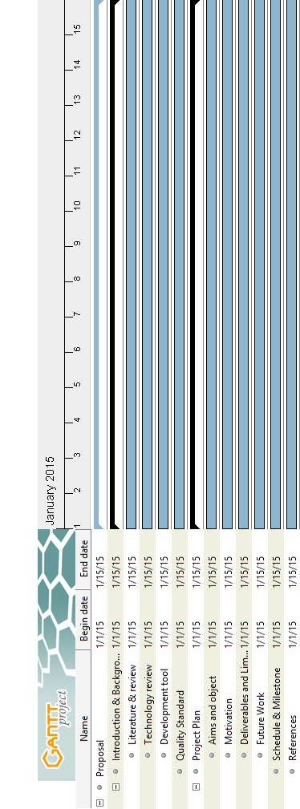

**Proposal Milestone**

*Figure 14 Proposal Period Milestone (Tentatively from early January to mid-January)*

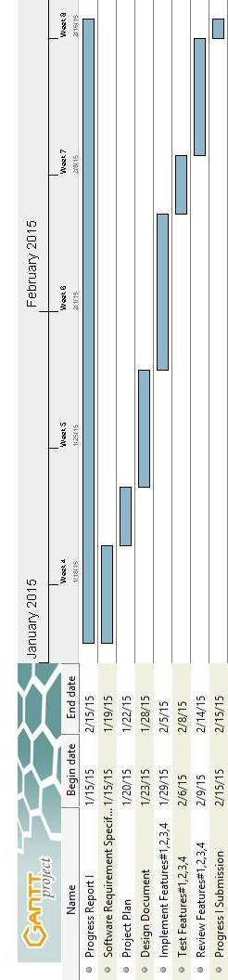

**Progress I**

*Figure 15 Progress I Period (Tentatively from mid-January to mid-February)*

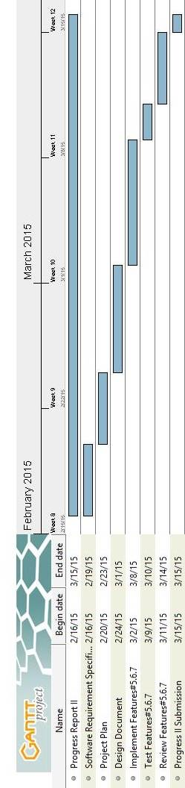

**Progress II**

*Figure 16 Progress II Period (Tentatively from mid-February to mid-March)*

# **Chapter Five | References**

[1] iSoftService

DATE 24/4/2015

<http://www.softnewer.com>

[2] ServiceCenter

DATE 24/4/2015

<http://www.programbunchee.com/scm.htm>

<http://www.thaiware.com>

[3] ASP.NET MVC

DATE 12/3/2015

[http://www.asp.net/mvc](http://www.asp.net/mvc%20)

[4] Cascading Style Sheets 3 (CSS3)

DATE 12/3/2015

<http://www.css3.info>

<http://www.w3schools.com/css/css3_intro.asp>

[5] HTML

DATE 12/3/2015

<http://www.w3schools.com/html>

[6] JavaScript

DATE 12/3/2015

<http://www.w3schools.com/js>

[7] Microsoft SQL Server

DATE 12/3/2015

[http://www.microsoft.com/sqlserver](http://www.microsoft.com/sqlserver%20)

[8] Microsoft Visual Studio

DATE 12/3/2015

<https://www.visualstudio.com>

<https://msdn.microsoft.com/en-us/vstudio>

[9] Mandrill

DATE 4/5/2015

<https://www.mandrill.com>

<https://mandrillapp.com>

[10] Window Azure

DATE 27/4/2015

<http://azure.microsoft.com>

[11] Internet Information Service (IIS)

DATE 24/4/2015

<http://www.iis.net>

[12] Bootstrap

DATE 4/5/2015

<http://getbootstrap.com>

<http://www.w3schools.com/bootstrap>

Figures

[1] *Figure 1 iSoftService's logo*

DATE 30/4/2015

<http://www.softnewer.com>

[2] *Figure 2 iSoftService main page Demo Version*

DATE 30/4/2015

<http://www.softnewer.com>

[3] *Figure 3 Service Center main page*

DATE 30/4/2015

<http://www.programbunchee.com/scm.htm>

http://www.vrtruelogic.com

[4] *Figure 4 Service Center repairing information page*

DATE 30/4/2015

<http://www.programbunchee.com/scm.htm>

<http://www.vrtruelogic.com>

[5] *Figure 5 ASP.NET MVC*

DATE 26/3/2015

<http://www.asp.net/mvc>

[6] *Figure 6 Cascading Style Sheets 3 (CSS3)*

DATE 26/3/2015

<http://www.css3.info>

[7] *Figure 7 HTML*

DATE 26/3/2015

<http://en.wikipedia.org/wiki/HTML>

[8] *Figure 8 JavaScript*

DATE 27/3/2015

<http://en.wikipedia.org/wiki/JavaScript>

[9] *Figure 9 MS SQL Server*

DATE 28/3/2015

<http://www.microsoft.com/sqlserver>

[10] *Figure 10 MS Visual Studio*

DATE 28/3/2015

<https://www.visualstudio.com>

[11] *Figure 11 Mandrill*

DATE 8/5/2015

<https://www.mandrill.com>

[12] *Figure 12 the architecture of Inventory and Asset Management system*

DATE 24/3/2015

[13] *Figure 13 Iterative development model*

DATE 24/3/2015

[14] *Figure 14 Proposal Period Milestone (Tentatively from early January to mid-January)*

DATE 21/5/2015

[15] *Figure 15 Progress I Period (Tentatively from mid-January to mid-February)*

DATE 21/5/2015

[16] *Figure 16 Progress II Period (Tentatively from mid-February to mid-March)*

DATE 21/5/2015